**GOVERNMENT COLLEGE FOR GIRLS NACHOLI Faridabad, Haryana – 121014**

**ANNUAL REPORT**

**Academic Session 2024–25**

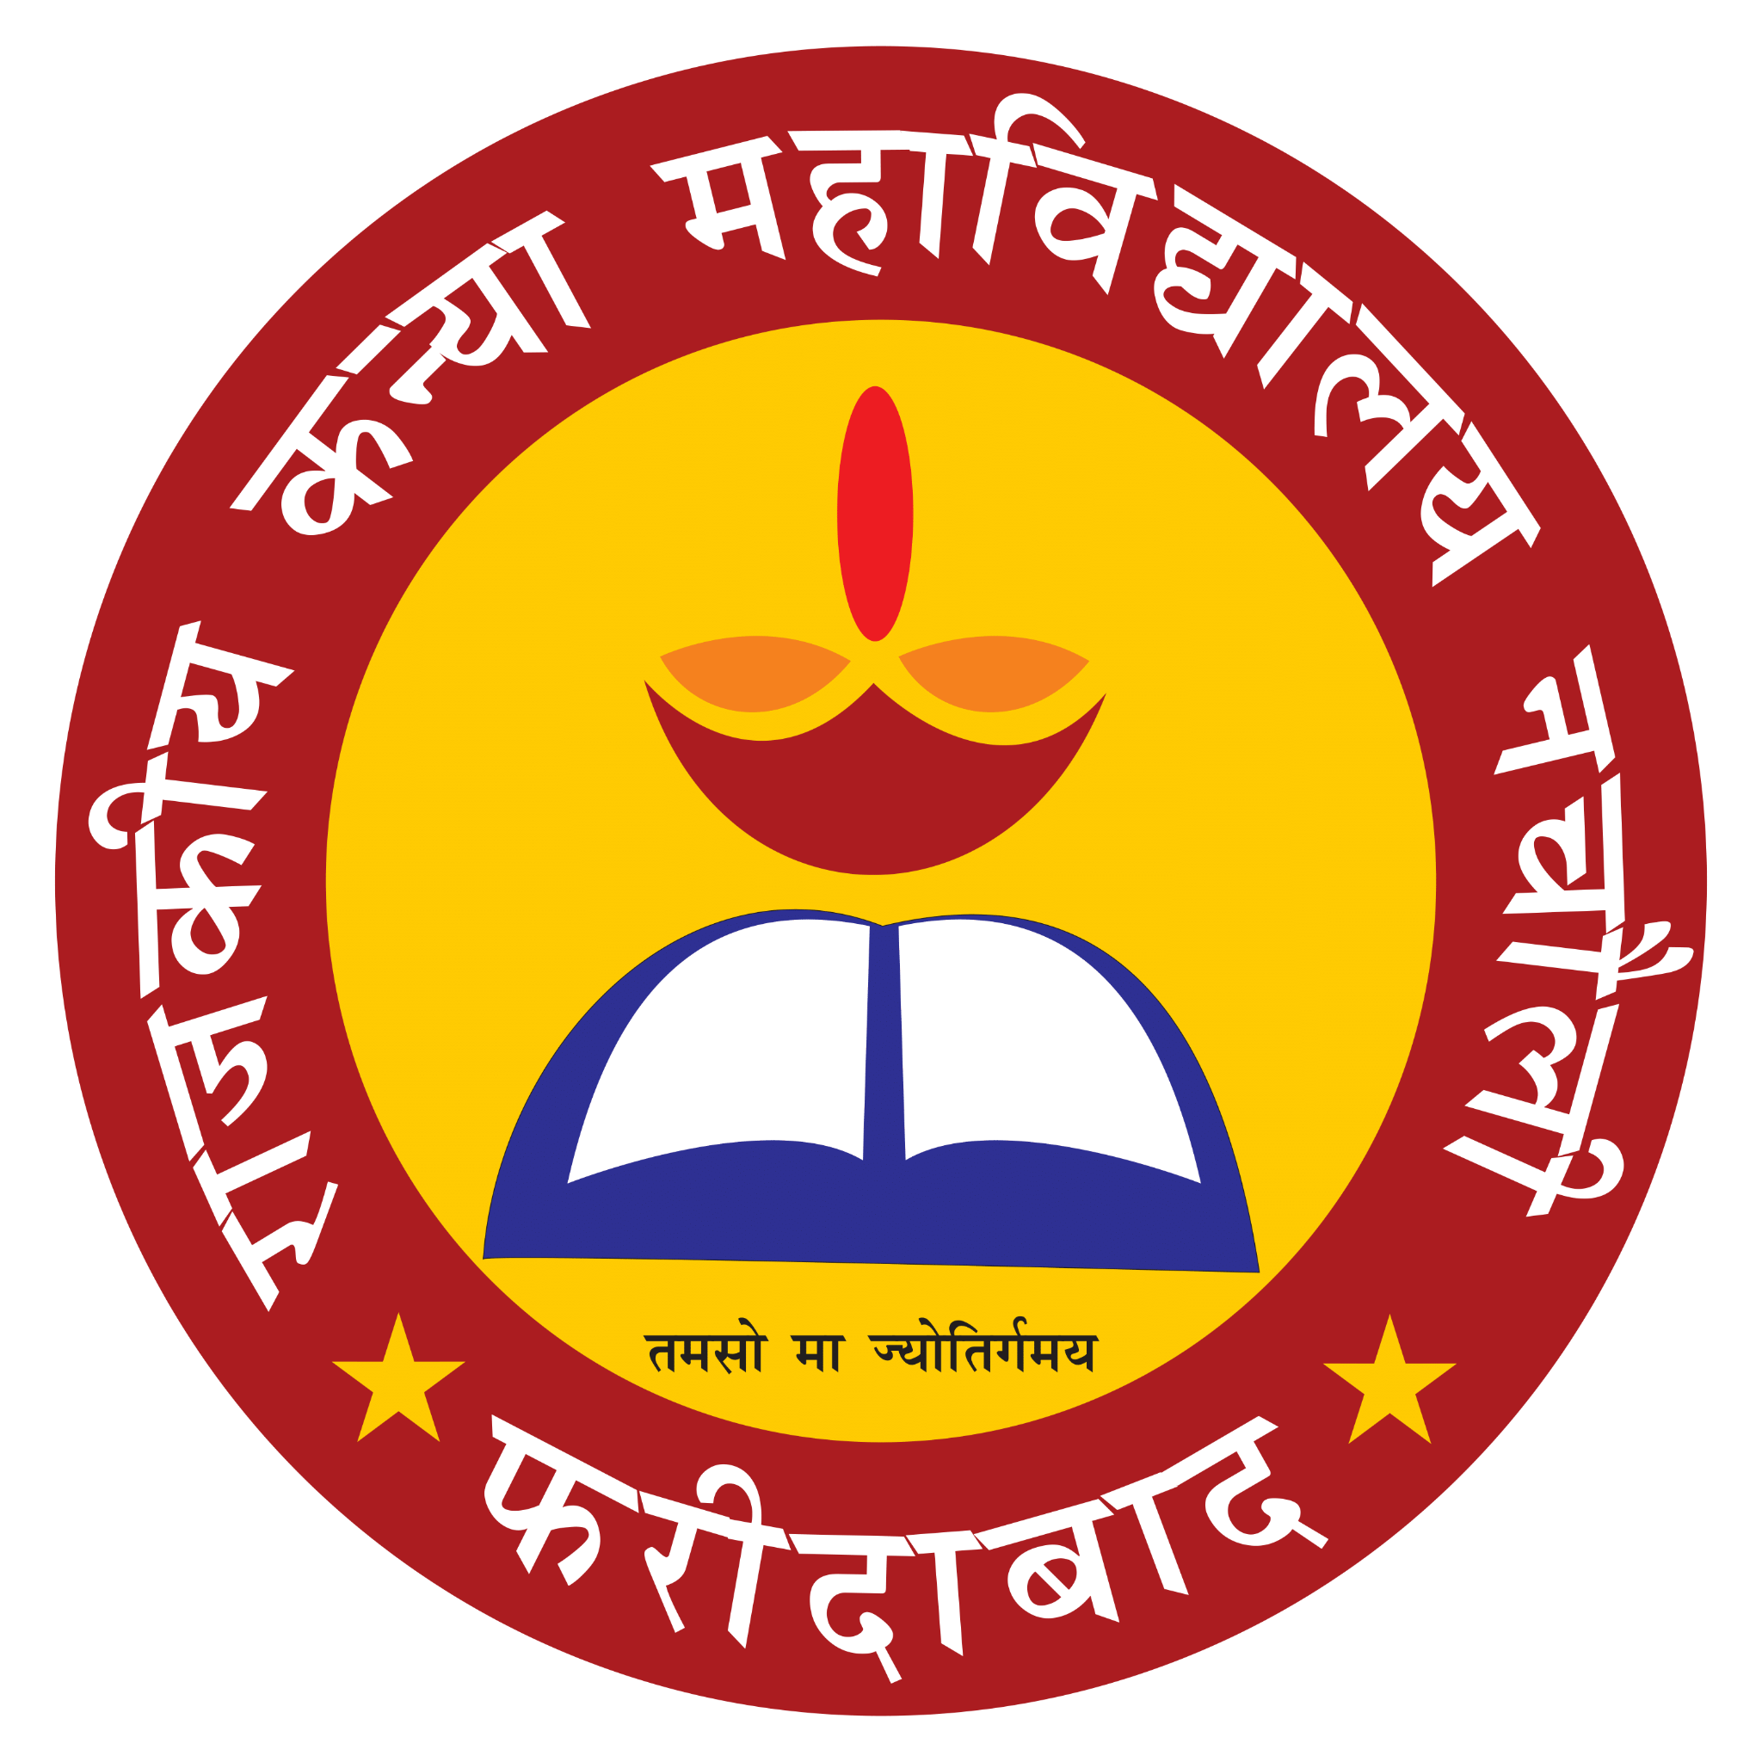

**Principal: Mrs. Archana Verma**

# Introduction

Government College for Girls, Nacholi, Faridabad, under the Directorate of Higher Education, Haryana, continues its commitment to women’s empowerment through holistic education. The academic session 2024–25 witnessed vibrant academic, cultural, and community-oriented activities aimed at nurturing the intellectual, creative, and social potential of students.

# Academic and Administrative Achievements

• Regular teaching–learning activities were conducted effectively throughout the year.

• The inspection for continuation of the BCA course was successfully held on 23rd August 2024.

• An MoU was signed with Aggarwal College, Ballabgarh on 16th December 2024 to enhance institutional collaboration and student development.

# Co-Curricular and Extracurricular Activities (2024–25)

|  |  |  |  |
| --- | --- | --- | --- |
| **S. No.** | **Event / Activity** | **Date(s)** | **Organizing Body / Theme** |
| 1 | Independence Day Celebration | 15th Aug 2024 | Patriotic Programme |
| 2 | Inspection for Continuation of BCA Course | 23rd Aug 2024 | Administrative Event |
| 3 | Teachers’ Day Celebration | 5th Sep 2024 | Cultural Committee |
| 4 | Beauty Workshop by VLCC | 19th Sep 2024 | Women Cell |
| 5 | Gandhi Jayanti & Quiz Competition | 1st Oct 2024 | Political Science Dept. |
| 6 | International Girl Child Day & Poster Making | 11th Oct 2024 | Women Cell |
| 7 | NSS One Day Camp | 15th Oct 2024 | NSS Unit |
| 8 | Mehandi Competition | 19th Oct 2024 | Cultural Committee |
| 9 | Talent Search Programme | 24th Oct 2024 | Cultural Committee |
| 10 | Constitution Day Lecture | 26th Nov 2024 | Political Science Dept. |
| 11 | MoU with Aggarwal College, Ballabgarh | 16th Dec 2024 | Collaboration |
| 12 | National Youth Day | 12th Jan 2025 | NSS Unit |
| 13 | NSS Seven Day Special Camp | 15th–21st Jan 2025 | NSS Unit |
| 14 | Workshop on Cybercrime & Digital Security | 16th Jan 2025 | Bhupani Police Station |
| 15 | Workshop on Road Safety & Drug Abuse | 19th Jan 2025 | Judicial Services Authority |
| 16 | Personality Dev. Training (Project Nimaya) | 23rd Jan–3rd Feb 2025 | Women Cell |
| 17 | National Voters’ Day | 25th Jan 2025 | NSS & Political Science |
| 18 | Republic Day Celebration | 26th Jan 2025 | Cultural Committee |
| 19 | 6th Annual Athletic Meet | 5th–6th Feb 2025 | Sports Dept. |
| 20 | International Women’s Day | 8th Mar 2025 | Women Cell |
| 21 | NSS One Day Camp | 8th Mar 2025 | NSS Unit |
| 22 | NSS Camp with Meditation | 28th Mar 2025 | NSS Unit |
| 23 | Cyclothon 2.0 (Drug Free Haryana) | 11th Apr 2025 | District Administration |
| 24 | Earth Day Celebration | 22nd Apr 2025 | Eco Club |
| 25 | Plantation Drive | 6th May 2025 | NSS & Eco Club |

# NSS and Social Outreach

The NSS Unit conducted multiple one-day and seven-day camps focusing on cleanliness, health awareness, meditation, and environmental sustainability. Students actively participated in Cyclothon 2.0 organized by the District Administration, Faridabad, promoting the theme 'Drug-Free Haryana'.

# Women Empowerment Initiatives

The Women Cell organized a variety of programs such as Beauty Workshop by VLCC, International Girl Child Day (Poster Making), and Project Nimaya (Personality Development & Communication Skills Training). These programs empowered students and enhanced their leadership skills.

# Youth Red Cross Society

Organized various activities during the session 2024-25 such as Anemia Health checkup camp was organized in the college and Deworming tablets were distributed among students on National Deworming Day. A lecture was also organized on “Women Health and importance of Hygiene” for the students.

# Sports and Fitness Activities

The 6th Annual Athletic Meet held on 5th–6th February 2025 showcased student enthusiasm and sportsmanship through track and field events.

# Environmental and Social Awareness Drives

Activities like Earth Day and Plantation Drive emphasized environmental responsibility and sustainability.

# Conclusion

The academic session 2024–25 was marked by academic excellence, community participation, and holistic development. The college continues to uphold its mission of empowering women through quality education and moral values.